Face Mask Detection

##### Using Machine Learning & Deep Learning

**Project Report**



## Submitted by

### Saiyam Jain. Roll: 41218002717 Mayank Goyal. Roll: 35118002717 Abhishek Aswal. Roll: 43318002717 Deepak Singh. Roll: 42918002717

## Under The Guidance Of

### Ms. Upasna Joshi Assistant Professor

### Department of Computer Science & Engineering

## CONTENTS

1. INTRODUCTION 3
2. BACKGROUND OF THE STUDY 4
3. LITERATURE SURVEY 6
4. SYSTEM ARCHITECTURE 7
5. RESULTS 8
6. SUMMARY 10
7. REFERENCES 11

# INTRODUCTION

Corona Virus was originated in Wuhan, China at the end of 2019. Since then, it has been spreading like a wild fire in a forest. Millions have been affected and around 1,668,356 have unfortunately passed away as on 18th of December 2020, almost a year since this virus came to existence. People who have this illness can take up to 2 weeks to cure, with the risk of having to suffer additional medical problems caused by it. Children and old people have proved to be at the highest risk to contract the disease, which may even result in death. Hence, it has been made a priority to contain the virus than to cure it. The virus spreads through the air, transmitted by one person to another not only by touch, but also by speaking and coughing. The concern was put forward to WHO (World Health Organization) which suggested that face masks and social distancing is the answer to it, until a cure is invented. Putting a face mask on can reduce the risk of getting infected by a great extent, not only to the one wearing it but also to the others that he comes in contact with. Wearing masks every time we go out is something we can do with little effort that can effectively save lives, and that is precisely why it is in so much demand at this point of time.

In this paper, we propose a Face Mask Detection project which consists of 2 phases, namely training and deployment. The first stage detects human faces, while the second phase uses deep learning to firstly, identify the ROI(Region Of Interest) being the person’s face and secondly classify the faces detected in the first stage as either ‘Mask’ or ‘No Mask’ faces and draws boundary of colors either green or red, depending on the output. The project takes JPG and PNG files as inputs, but it has also been tested on videos. The project can give accurate results if set up with a CCTV camera to track people without masks to ensure the safety and wellbeing of others, thus help controlling the spread of the virus.

We have also created a website which allows anyone to either run the code online directly or download the android application through which face mask detection can be started.

# Background of the study

#### Object detection.

##### Object detection is a computer vision technique that allows you to locate and locate objects in an image or video. With such identification and localization, object detection is used to count objects in a scene and to locate and track their exact locations, while all are labeled correctly. The algorithm generates an axis-aligned boundary box showing a list of object categories in the image and the position and level of each instance of each object category.

#### CNN

##### CNN plays an important role in computer vision prototype recognition because of its superior spatial capability Extraction capacity and low computational cost. CNN uses decision kernels to interact with the original Image or feature maps to remove high-end features. However, how to properly design a never-ending network neural Architecture is still a fundamental question. The installation network allows you to find out the proposal network. The best combination of kernels. To train very deep neural networks, K. Heet Al and others proposed residual network (Resnet), which can learn identity mapping from the previous layer. The object detector is usually set Mobile networks (mobile net) are mobile or embedded devices whose computing resources are very limited [29]. Proposed. It uses in-depth discernment to capture features and channel wise resolutions according to channel numbers. Therefore the computational cost of mobile net is much lower than networks that use standard resolutions.

#### Machine learning

##### Machine learning algorithms are used in a wide variety of applications, such as email filtering and computer vision, where it is difficult or infeasible to develop conventional algorithms to perform the needed tasks. Machine learning is closely related to computational statistics, which focuses on making predictions using computers. Data mining is a related field of study, focusing on exploratory data analysis through unsupervised learning. In its application across business problems, machine learning is also referred to as predictive analytics.

#### Deep Learning

##### Deep learning methods aim at learning feature hierarchies with features from higher levels of the hierarchy formed by the composition of lower level features. Automatically learning features at multiple levels of abstraction allow a system to learn complex functions mapping the input to the output directly from data, without depending completely on human-crafted features. Deep learning allows computational models that are composed of multiple processing layers to learn representations of data with multiple levels of abstraction.

#### MobileNetV2

##### MobileNetV2 is a state of the art for mobile visual recognition including classification, object

##### detection and semantic segmentation. This classifier uses Depth wise Separable Convolution which is introduced to dramatically reduce the complexity cost and model size of the network, and hence is suitable to Mobile devices, or devices that have low computational power. In MobileNetV2, another best module that is introduced is inverted residual structure. Non-linearity in narrow layers is deleted. Keeping MobileNetV2 as backbone for feature extraction, best performances are achieved for object detection and semantic segmentation.

##### 

#### HTML

##### The HyperText Markup Language, or HTML is the standard markup language for documents designed to be displayed in a web browser. It can be assisted by technologies such as Cascading Style Sheets (CSS) and scripting languages such as JavaScript.

##### Web browsers receive HTML documents from a web server or from local storage and render the documents into multimedia web pages. HTML describes the structure of a web page semantically and originally included cues for the appearance of the document.

#### CSS

##### Cascading Style Sheets (CSS) is a style sheet language used for describing the presentation of a document written in a markup language such as HTML. CSS is a cornerstone technology of the World Wide Web, alongside HTML and JavaScript.

##### CSS is designed to enable the separation of presentation and content, including layout, colors, and fonts. This separation can improve content accessibility, provide more flexibility and control in the specification of presentation characteristics, enable multiple web pages to share formatting by specifying the relevant CSS in a separate .css file which reduces complexity and repetition in the structural content as well as enabling the .css file to be cached to improve the page load speed between the pages that share the file and its formatting.

#### Android Studio

##### Android Studio is the official integrated development environment (IDE) for Google's Android operating system, built on JetBrains IntelliJ IDEA software and designed specifically for Android development. It is available for download on Windows, macOS and Linux based operating systems or as a subscription-based service in 2020. It is a replacement for the Eclipse Android Development Tools (E-ADT) as the primary IDE for native Android application development.

#### Javascript

##### JavaScript often abbreviated as JS, is a programming language that conforms to the ECMAScript specification. JavaScript is high-level, often just-in-time compiled, and multi-paradigm. It has curly-bracket syntax, dynamic typing, prototype-based object-orientation, and first-class functions.

Alongside HTML and CSS, JavaScript is one of the core technologies of the er 97% of websites use it client-side for web page behavior often incorporating third-party libraries. All major web browsers have a dedicated JavaScript engine to execute the code on the user's device.

1. **Literature Survey**

Deep learning techniques are useful for big data analysis and include applications in computer vision, design and speech recognition. After reading Z. Wang, G. Wang, (2020), “Masked face recognition dataset and application we recognize that this work will focus on some of the most commonly implemented intensive learning architectures and their applications. Auto-encoder, good neural networks, Boltzmann machines, Deep Trust networks are the networks presented in detail. Deep learning can be used in un-enhanced learning algorithms to process unplugged data.

Previously, Khandelwal in his research work (2020) had stated in his work about a deep learning model that binaries an image as a mask is used or not mask. 380 images had a mask and 460 images had no mask and these images were used in the training of the MobileNetV2 model.

Qin B. and Li D. has done a face mask recognition project that focuses on capturing real-time images indicating whether a person has put on a face mask or not. The dataset was used for training purposes to detect the main facial features (eyes, mouth, and nose) and for applying the decision- making algorithm. Putting on glasses showed no negative effect. Rigid masks gave better results whereas incorrect detections can occur due to illumination, and to objects that are noticeable out of the face.

# SYSTEM ARCHITECTURE

This system aims at classifying whether a person is wearing a mask or not by taking input from images real time streaming videos. We have taken a total of 3847 images in our Face Mask Detection Dataset belonging to two labels i.e. with mask: 1917 images and without mask: 1930 images. The classification of the images is done by training the model in 2 phases:

Phase 1: Training- Training the model on the dataset using Tensorflow & Keras with classifier like MobileNetV2 is used to generate a trained model.

Phase2: Deployment - Loading the trained model and applying detector over images/live video stream

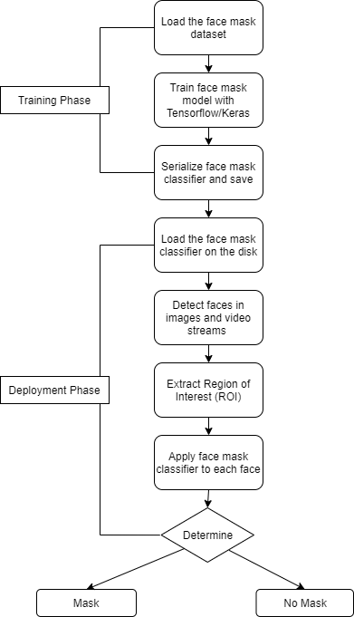

# Results

We created a face mask detector using Deep Learning, Keras, Tensorflow and OpenCV. We trained it to distinguish between people wearing mask and people not wearing a mask We have used MobileNet V2 classifier with the ADAM optimizer for the best result.

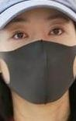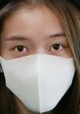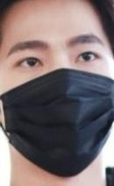

**Some images of with mask dataset**

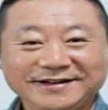

**Some images of without mask dataset**

**Test Outputs**

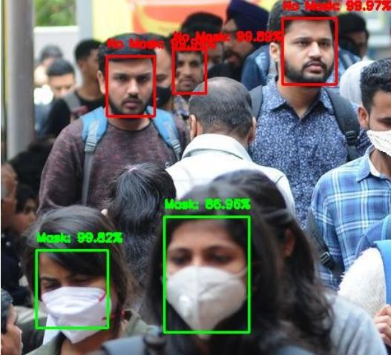

**Output of Face Mask Detector in Uploaded Image**

The accuracy of the model is calculated to be 98%.

It is observed that performance of ADAM optimizer is good in both training and testing.

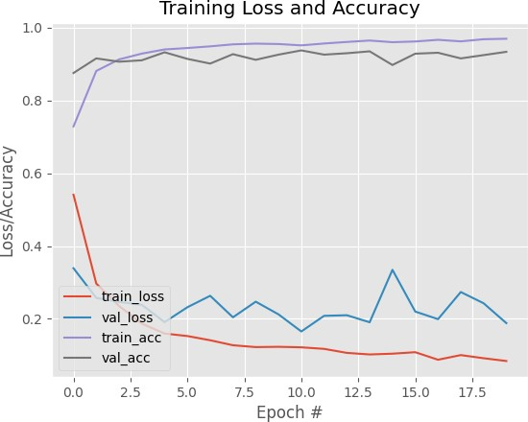

**Accuracy/Loss Plot**

**Website**

The website can be accessed by the url <http://covid-fmd.netlify.app/> where a person can either run the code directly online or download the application. The development of the website was important so that our project can reach out to people to be put in good use for the society.

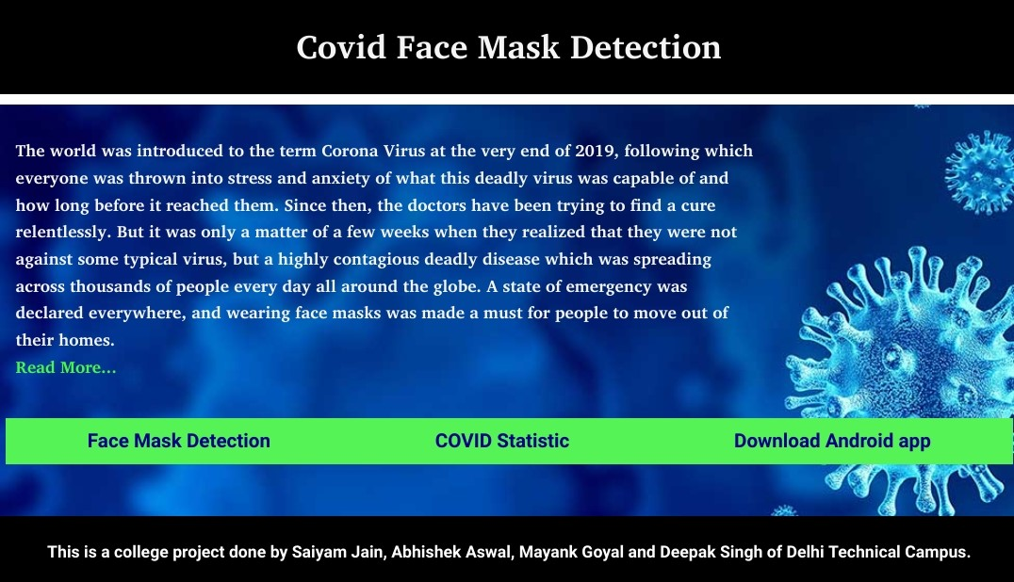

# SUMMARY

As the technology are blooming with emerging trends the availability so we have novel face mask detector which can possibly contribute to public healthcare. The architecture consists of Mobile Net as the backbone it can be used for high and low computation scenarios. In order to extract more robust features, we utilize transfer learning to adopt weights from a similar task face detection, which is trained on a very large dataset. We used OpenCV, Tensorflow, Keras , Pytorch and CNN to detect whether people were wearing face masks or not. The models were tested with images and real-time video streams. The accuracy of the model is achieved and, the optimization of the model is a continuous process and we are building a highly accurate solution by tuning the hyper parameters. This specific model could be used as a use case for edge analytics. Furthermore, the proposed method achieves state-of-the-art results on a public face mask dataset. By the development of face mask detection we can detect if the person is wearing a face mask and allow their entry would be of great help to the society.

# REFERENCES

* 1. S. Feng, C. Shen, N. Xia, W. Song, M. Fan, and B. J. Cowling, “Rational use of face masks in the covid-19pandemic,”The Lancet Respiratory Medicine, 2020.
  2. Y. Fang, Y. Nie, and M. Penny, “Transmission dynamics of the covid-19 outbreak and effectiveness of government interventions: A data-driven analysis, “Journal of medical virology, vol. 92, no. 6, pp. 645–659, 2020.
  3. Z. Wang, G. Wang, B. Huang, Z. Xiong, Q. Hong, H. Wu, P. Yi, K. Jiang, N. Wang, Y. Peiet al., “Masked face recognition dataset and application” arXiv preprint arXiv:2003.09093, 2020.
  4. Z.-Q. Zhao, P. Zheng, S.-t. Xu, and X. Wu, “Object detection with deep learning: A review”, IEEE transactions on neural networks and learning systems, vol. 30, no. 11, pp. 3212–3232, 2019.
  5. Qin B. and Li D. , Identifying face mask wearing condition using image super-resolution with classification network to prevent COVID-19.doi: 10.21203/rs.3.rs-28668/v1
  6. Erhan, D., Szegedy, C., Toshev, A., and Anguelov, D. (2014). “Scalable object detection using deep neural networks,” in Computer Vision and Pattern Recognition Frontiers in Robotics and AI
  7. R. Girshick, J. Donahue, T. Darrell, and J. Malik, “Rich feature hierarchies for accurate object detection and semantic segmentation,” in Proceedings of the IEEE conference on computer vision and pattern recognition, 2014.
  8. A. Kumar, A. Kaur, and M. Kumar, “Face detection techniques: a review,”Artificial Intelligence Review, vol. 52,no. 2, pp. 927–948, 2019.D.-H. Lee, K.-L. Chen, K.-H. Liou, C.-L. Liu, and J.-L. Liu, “Deep learning and control algorithms of direct perception for autonomous driving, 2019.

.